**“ Railway Reservation System”**

**SUBMITED BY**

1. Gaurav Rane (80)

2. Sriraj Takalkar (101)



**Department Of Computer Application.**

**K.K.Wagh Arts, Commerce, Science and Computer Science College.**

**Nashik-422003**

**Academic Year 2024-25**



Karmaveer Kakasaheb Wagh Education Society’s

**K. K. Wagh Arts Commerce, Science, & Computer Science College**

**Saraswati Nagar Nashik-422003**

**C E R T I F I C A T E**

This is to certify that,

**Mr**./**Miss Gaurav Pradip Rane**

has satisfactory completed his/her/their project Railway Resurvation System as fulfillment in **T.Y.B.B.A.(Computer Application)** Class for the academic year **2024-2025**.

Project Done by: Gaurav Pradip Rane

Shriraj Prasad Takalkar

Project Guide H.O.D

Internal Examiner External Examiner



Karmaveer Kakasaheb Wagh Education Society’s

**K. K. Wagh Arts Commerce, Science, & Computer Science College**

**Saraswati Nagar Nashik-422003**

**C E R T I F I C A T E**

This is to certify that,

**Mr**./**Miss Shiraj Prasad Takalkar**

has satisfactory completed his/her/their project Railway Resurvation System as fulfillment in **T.Y.B.B.A.(Computer Application)** Class for the academic year **2024-2025**.

Project Done by: Gaurav Pradip Rane

Shriraj Prasad Takalkar

Project Guide H.O.D

Internal Examiner External Examiner



Karmaveer Kakasaheb Wagh Education Society’s

**K. K. Wagh Arts Commerce, Science, & Computer Science College**

**Saraswati Nagar Nashik-422003**

**C E R T I F I C A T E**

This is to certify that,

**Mr**./**Miss Gaurav Pradip Rane and Shriraj Prasad Takalkar**

has satisfactory completed his/her/their project Railway Reservation System as fulfillment in **T.Y.B.B.A.(Computer Application)** Class for the academic year **2024-2025**.

Project Done by: Gaurav Pradip Rane

Shriraj Prasad Takalkar

Project Guide H.O.D

Internal Examiner External Examiner

**Index - Application Project**

|  |  |  |
| --- | --- | --- |
| **Sr. No** | **Documentation Content** | **Page No** |
| **I** | **Introduction** | |
| 1 | Motivation |  |
| 2 | Problem Statement |  |
| 3 | Purpose / Objective and Goals |  |
| 4 | Literature Survey |  |
| **II** | **System analysis** | |
| 1 | Existing Systems |  |
| 2 | Scope and Limitations of Existing Systems |  |
| 3 | Project Perspective , Features , Stakeholders |  |
| 4 | Requirement Analysis -  Functional requirements, Performance requirements,  Security requirements etc |  |
| **III** | **System Design** | |
| 1 | ERD |  |
| 2 | Data Dictionary |  |
| 3 | Use Case, Sequence, Activity, Component, Deployment Diagram |  |
| 4 | User Interfaces |  |
| **IV** | **Implementation details** | |
| 1 | Software / Hardware Specifications |  |
| **V** | **Outputs and Reports Testing** | |
| 1 | Screenshot and Report |  |

**Introduction**

**Motivation**

We own our sincere gratitude to all those people who have given us their constant support and encouragement without which our project report would not have reached this stage.

We would like to express our thanks to Prof V.H Bava for her advice and encouragement. She has been a pillar of strength right through the project till the preparation of this report and helped by boosting morale, so we could surmount the difficulties that came across during completion of this project.

We would like to express our gratitude to Dr. S.V. Patil , Principal, K.K.Wagh Arts, commerce, science and Computer Science College and Prof.Vijayshri Bava, Head of Computer Application department for the support and the infrastructure they have provided, so that we could successfully complete the project on time.

Last but not the least, we would like to express our sincere thanks to all staff members and our friends for their help and cooperation in all phases of the project.

1. -------------------------------------
2. -------------------------------------

**2. Problem Statement**

The Railway Reservation System aims to improve and automate the train ticket booking process, enabling passengers to efficiently search for available trains, book and cancel tickets, and check booking status online. The current system relies heavily on manual processes, such as visiting physical reservation counters, which results in long waiting times and limited access to train information. Additionally, there is no option for passengers to provide or view reviews for trains, making it difficult to assess service quality.

The objective of this project is to design and implement a computerized Railway Reservation System that allows users to:

1. Book and cancel tickets online.
2. Search for trains based on source, destination, and date.
3. View booking status and train information in real-time.
4. Submit and read reviews for specific trains.

This system will enhance convenience, reduce waiting times, and offer better access to important travel information for passengers.

**3. Purpose / Objective**

The **purpose** of the Railway Reservation System is to create a more efficient and user-friendly platform for passengers to book train tickets, access train schedules, and manage their bookings online. It aims to eliminate the need for physical reservation counters, reduce manual ticketing processes, and provide better access to train-related information, enhancing the overall travel experience.

**Goals :**

1. **Online Booking and Cancellation**: To provide passengers with the ability to book and cancel tickets online, making the process more convenient and accessible.
2. **Real-time Train Information**: To enable users to search for available trains based on source, destination, and date, with real-time updates on seat availability, departure, and arrival times.
3. **Comprehensive Review System**: To allow passengers to submit and view reviews and ratings for trains, improving transparency and helping others make informed decisions.
4. **Time Efficiency**: To significantly reduce the time spent in booking or canceling tickets by replacing manual procedures with automated, real-time processes.
5. **Enhanced User Experience**: To improve passenger satisfaction by providing a seamless, easy-to-use, and responsive platform for booking and managing train journeys.
6. **Transparency and Feedback**: To introduce a review system that provides insights into train services, allowing users to make informed travel decisions based on peer feedback.

These goals aim to modernize the traditional railway reservation system, making it more accessible, efficient, and responsive to user needs.

**4. Literature Survey**

The **Railway Reservation System** has evolved significantly over the years from manual ticket booking at counters to online systems. To better understand the development and scope of this project, this literature survey examines the existing systems, challenges faced by traditional methods, and recent advancements in railway reservation technologies.

**1. Traditional Reservation Systems:**

In the past, railway reservations were handled manually through reservation counters and authorized agents. Passengers had to physically visit these counters to book, cancel, or modify their tickets. This system had several limitations:

* **Time-Consuming Process:** The manual filling of forms and long queues at counters during peak seasons made ticket booking a tedious and time-intensive process.
* **Limited Information Access:** Passengers had to rely on printed schedules or information provided by agents, which was often outdated or incomplete.
* **No Real-Time Updates:** There was no provision for real-time availability of trains or seats, leading to issues like overbooking or lack of transparency.

**Example:** Indian Railways, before its transition to online platforms, relied heavily on manual reservation systems, where passengers could only book tickets through railway counters or travel agencies.

**2. Introduction of Online Railway Reservation Systems:**

With the advent of internet-based systems, many railway networks began transitioning to online reservation platforms. These systems offered users the convenience of booking tickets from home, checking train schedules in real time, and making cancellations without visiting a physical counter.

* **IRCTC (Indian Railway Catering and Tourism Corporation):** One of the most successful online railway reservation systems, IRCTC revolutionized the way passengers book train tickets in India. It introduced features such as real-time availability, online payment gateways, and automatic waitlist management.
* **Benefits of Online Systems:**
  + **Convenience:** Passengers can book, cancel, and modify tickets from any location.
  + **Real-Time Information:** Users can access up-to-date information on train availability, seat occupancy, and schedule changes.
  + **User Feedback:** Online platforms allowed for the introduction of a review system where users could provide feedback on their travel experiences.

**Limitations of Early Online Systems:**

* **Technical Difficulties:** In the early stages, online systems faced frequent downtime due to server overload during peak times.
* **Security Concerns:** Online transactions were initially prone to security breaches, with concerns about the safety of personal and financial data.

**3. Modern Features and Enhancements:**

Modern railway reservation systems have incorporated advanced features to improve user experience and efficiency:

* **Mobile Applications:** With the growing use of smartphones, many railway networks introduced mobile apps for easier access to ticket booking and travel information.
* **Dynamic Seat Selection:** Passengers can view the real-time seat layout and select their preferred seats while booking.
* **Personalized User Profiles:** Modern systems now allow users to create accounts, save travel preferences, and track their booking history.
* **Review and Rating Systems:** Passengers can provide feedback on trains and services, which helps others make informed travel decisions.
* **Integration with Third-Party APIs:** Many systems integrate with APIs to provide additional services, such as real-time train tracking, weather updates, and alternative travel suggestions.

**Example:** The UK’s National Rail Enquiries platform provides an integrated online reservation system that allows users to check seat availability, make bookings, and receive real-time alerts on train delays or cancellations.

**4. Challenges in Current Systems :**

Despite the advancements, current railway reservation systems still face several challenges:

* **Scalability Issues:** During peak seasons or festival times, even modern systems struggle with server load, leading to slow response times or downtime.
* **User Adoption and Technical Literacy:** In some regions, passengers are not comfortable with using online systems, especially in rural areas with limited internet connectivity.
* **Data Privacy and Security:** As online systems handle sensitive passenger data, they remain vulnerable to security breaches, necessitating the use of encryption and regular audits.

**5. Technological Trends in Railway Reservation Systems :**

Emerging technologies are helping to overcome the limitations of traditional and current systems:

* **Artificial Intelligence and Machine Learning:** These technologies are being used for predictive analytics, where systems can analyze passenger behavior and recommend trains based on past travel patterns.
* **Cloud Computing:** Modern systems are migrating to cloud-based infrastructures to provide better scalability, reliability, and real-time processing power.
* **Blockchain for Ticketing:** Some researchers have proposed the use of blockchain to create decentralized ticketing systems, ensuring transparency, security, and preventing fraud.

**6. Comparative Analysis :**

A comparison of various railway reservation systems highlights the progress made:

* **Indian Railways (IRCTC)** vs. **National Rail (UK)**: While both systems offer online booking, National Rail provides a more integrated approach with real-time train tracking and seamless API integrations. IRCTC, on the other hand, has a much larger user base but struggles with scalability during peak times.
* **Amtrak (USA):** Amtrak's system offers dynamic seat allocation and online meal booking services. However, it lacks a comprehensive user feedback system, unlike IRCTC, which has a robust review platform.

**7. Future Scope and Enhancements :**

The railway reservation systems of the future are expected to incorporate:

* **Mobile Wallet Integration:** To make payments more seamless for users by integrating widely-used payment wallets.
* **Predictive Maintenance and Scheduling:** Using IoT and AI to predict train delays or cancellations and inform passengers accordingly.
* **Cross-platform Integration:** Allowing seamless booking across different modes of transport (train, bus, taxi) for complete travel solutions.

**Conclusion**

The literature survey highlights the evolution of railway reservation systems from manual, paper-based processes to sophisticated online platforms. With continuous improvements in technology, the future of railway reservation systems will focus on enhancing user convenience, improving real-time information delivery, and ensuring data security. The development of this Railway Reservation System aims to incorporate modern trends to offer a user-friendly and efficient solution.

**System Analysis**

**1. Existing System: Railway Reservation System**

The traditional **Railway Reservation System** relied heavily on offline processes, which posed several challenges for both passengers and the railway administration. The key aspects and limitations of the existing system are as follows:

**1. Reservation Counters :**

* **Manual Ticket Booking**: Passengers have to visit physical reservation counters to inquire about train schedules, check seat availability, and book tickets.
* **Long Queues and Waiting Times**: During peak travel seasons or holidays, long queues at the counters lead to significant waiting times for passengers.
* **Limited Operational Hours**: Reservation counters operate only during specific hours, restricting passengers from booking tickets at their convenience.

**2. Manual Ticketing Process**

* **Time-Consuming**: The entire process of filling out forms, entering passenger details, and issuing tickets is done manually, which slows down the system.
* **Prone to Errors**: Manual data entry is prone to mistakes, such as incorrect passenger details or seat allocation errors.
* **Physical Tickets**: Tickets are provided as physical documents, and passengers are required to keep them safe for boarding the train.

**3. Limited Information Access**

* **No Real-Time Information**: Passengers rely on printed schedules or the knowledge of reservation agents for train timings and availability. There is no provision for real-time updates on seat availability, train delays, or cancellations.
* **Restricted Availability**: Only passengers who visit the counter have access to information on train availability, and there is no centralized platform for this data.

**4. No Online Booking or Cancellation**

* **Offline Process Only**: Passengers cannot book or cancel tickets online. They must physically visit the reservation counters to make any changes to their bookings.
* **Inconvenience**: This lack of online accessibility creates inconvenience, especially for those who live far from reservation counters or need to make urgent bookings.

**5. No Review System**

* **Lack of Feedback Mechanism**: Passengers do not have the option to provide feedback or reviews about their travel experiences.
* **No Transparency**: The absence of reviews means passengers cannot assess the quality of service, cleanliness, or facilities on specific trains before booking.

**6. Time-Consuming and Cumbersome**

* **Manual Processes**: Both the ticketing and cancellation processes are time-consuming due to manual procedures.
* **No Automation**: The system relies heavily on human resources, which limits the efficiency of the service, especially during high-demand periods.

**7. Lack of Transparency and Service Quality Insights**

* **No Review Visibility**: Without a system for passengers to review trains, it is difficult to assess the quality of services, such as punctuality, cleanliness, or comfort.
* **Limited Customer Feedback**: Feedback and complaints are generally handled manually, with no structured system for tracking or addressing passenger concerns.

**Summary of Limitations in the Existing System :**

1. **Manual and Paper-Based**: The entire booking process is manual and inefficient.
2. **No Online Services**: No online platform for booking, cancellation, or reviewing train services.
3. **Limited Information Access**: Passengers cannot easily access real-time information on train schedules or seat availability.
4. **Lack of Feedback and Reviews**: There is no system to collect or display passenger reviews, which leads to a lack of transparency.
5. **Inconvenience for Users**: The need to visit reservation counters causes delays and frustration, especially during peak times.

These limitations in the existing railway reservation system highlight the need for a more modern, digital solution that offers online booking, real-time updates, and enhanced user experiences.

**2. Scope and Limitations of the Existing Railway Reservation System**

**Scope of the Existing System:**

The existing Railway Reservation System, while functional, has a limited scope primarily focused on providing basic ticket booking services through manual processes. The key areas of operation include:

1. **Basic Ticket Booking**:
   * Passengers can visit physical counters to inquire about trains, check seat availability, and book tickets for their journey.
   * The system allows manual booking through reservation agents at designated locations.
2. **Train Schedule and Seat Availability**:
   * The system provides information on available trains, seats, and basic schedules to passengers who visit reservation counters.
3. **Ticket Cancellation**:
   * Passengers can cancel their tickets by visiting the reservation counters, and refunds are processed manually according to railway policies.
4. **Booking Through Travel Agents**:
   * Authorized travel agents can also access the system to book tickets on behalf of passengers.

**Limitations of the Existing System :**

The limitations of the existing system are significant and present multiple challenges for passengers and railway authorities alike:

1. **No Online Booking or Cancellation**:
   * The system does not support online ticket booking or cancellation, forcing passengers to visit physical reservation counters for all bookings and changes.
   * This limits convenience and accessibility, especially for passengers in remote areas or those needing urgent bookings.
2. **Manual and Time-Consuming Process**:
   * All operations, including booking, cancellations, and checking availability, are performed manually, leading to long waiting times, especially during peak seasons.
   * Manual data entry and ticket issuance can result in errors and inefficiencies.
3. **Limited Information Access**:
   * Passengers must rely on reservation agents or printed schedules for train availability and timings.
   * There is no provision for real-time updates on seat availability, train delays, or schedule changes.
4. **Lack of Transparency and Review System**:
   * The system does not provide passengers with a way to review or assess the quality of services provided by different trains.
   * Passengers have no insight into the punctuality, cleanliness, or comfort of trains before making a booking, which can lead to dissatisfaction.
5. **Restricted Operational Hours**:
   * Reservation counters operate only during certain hours, restricting passengers from booking tickets outside of these times.
   * This limits the flexibility and availability of booking services.
6. **Geographical Limitations**:
   * Passengers must physically visit counters, which can be far from their location, making it difficult for those in rural areas or people with limited mobility to book tickets.
7. **Lack of Automation**:
   * The absence of automated systems means the process is slow, requiring significant human intervention for even simple operations like booking and cancellations.
8. **No Centralized System for Data Management**:
   * Since bookings are done manually at different counters, there is no centralized real-time system that passengers or administrators can use to track bookings, check seat availability, or manage schedules efficiently.
9. **Dependence on Reservation Agents**:
   * Passengers have to rely on reservation agents for all information, which may sometimes lead to delays or incorrect information being provided due to human error.

**Summary of Scope and Limitations :**

* **Scope**: Basic offline ticket booking and cancellation through physical reservation counters and agents.
* **Limitations**:
  + No online services for booking or cancellation.
  + Manual, time-consuming processes with high chances of error.
  + Lack of real-time information, transparency, and customer feedback systems.
  + Limited accessibility due to operational hours and geographical constraints.
  + Heavy reliance on human resources and manual operations, making the system inefficient and prone to delays.

These limitations underscore the need for a modernized, online system to enhance accessibility, efficiency, and customer satisfaction.

**3. Project Perspective, Features, Stakeholders**

**a) Project Perspective:**

The **Railway Reservation System** aims to provide a comprehensive solution for booking train tickets, enhancing passenger convenience, and modernizing the ticketing process. The project perspective emphasizes the need for a user-friendly, efficient, and automated system that addresses the limitations of traditional railway reservation methods. It envisions a platform where passengers can easily access train schedules, book and cancel tickets online, and provide feedback on their travel experiences. The system is designed to cater to the evolving needs of travelers in the digital age, focusing on:

* **User-Centric Design**: Ensuring that the interface is intuitive and accessible for all users, including those with limited technical skills.
* **Real-Time Data Access**: Providing real-time updates on train availability, schedules, and bookings.
* **Robust Security Measures**: Protecting user data and financial transactions through encryption and secure authentication methods.
* **Scalability**: Building a system capable of handling a large number of concurrent users, especially during peak travel seasons.

**b) Features:**

The Railway Reservation System encompasses various features aimed at improving user experience and operational efficiency:

1. **User Registration and Authentication**:
   * Secure user accounts allowing passengers to register, log in, and manage their profiles.
2. **Train Search and Booking**:
   * A search interface for users to find trains based on source, destination, and travel date.
   * Display of available trains with details like departure and arrival times, duration, and seat availability.
   * Online ticket booking with integrated payment gateways for secure transactions.
3. **Ticket Cancellation**:
   * An easy-to-use interface for users to cancel their booked tickets online, including automated refund processing.
4. **Comprehensive Review System**:
   * A feature enabling passengers to submit and view reviews and ratings for specific trains based on their travel experiences.
5. **User Profile Management**:
   * Personalized profiles that allow users to save travel preferences, view booking history.
6. **Admin Dashboard**:
   * A management interface for administrators to monitor bookings, manage train schedules.
7. **Data Analytics**:
   * Reporting tools for analyzing booking trends, user demographics, and service quality based on passenger reviews.

**c) Stakeholders:**

The development and implementation of the Railway Reservation System involve several key stakeholders, each with distinct roles and interests:

1. **Passengers/Users**:
   * The primary users of the system who will benefit from the convenience of online booking, cancellations, and real-time information.
2. **Railway Administration**:
   * Responsible for overseeing the railway operations and ensuring the system meets regulatory and operational standards.
3. **System Developers**:
   * The technical team involved in the design, development, testing, and deployment of the system.
4. **IT Support Team**:
   * Responsible for maintaining the system, ensuring uptime, handling technical issues, and providing user support.
5. **Project Managers**:
   * Oversee the project timeline, budget, and coordination between various teams to ensure successful project delivery.
6. **Travel Agents**:
   * Authorized agents who may use the system to book tickets on behalf of passengers, providing additional support and services.
7. **Regulatory Authorities**:
   * Government bodies that regulate railway operations, ensuring compliance with laws and safety standards.
8. **Marketing and Customer Service Teams**:
   * Responsible for promoting the system, educating users about its features, and providing assistance to customers.

**Summary**

The Railway Reservation System is designed to modernize the ticket booking process, offering user-friendly features while addressing the limitations of existing systems. By identifying key stakeholders and their roles, the project can be effectively managed to ensure that the system meets the needs of all users and contributes to a more efficient railway reservation process.

**4. Requirement Analysis**

Requirement analysis is a crucial step in the development of the Railway Reservation System, as it helps define what the system should achieve. This analysis is categorized into three main types of requirements: functional requirements, performance requirements, and security requirements.

**1. Functional Requirements :**

Functional requirements specify what the system should do and describe its functionalities. For the Railway Reservation System, the key functional requirements include:

1. **User Registration and Authentication**:
   * Users must be able to create an account by providing personal information (name, email, password, etc.).
   * The system should validate user credentials during the login process.
2. **Train Search**:
   * Users should be able to search for trains based on source, destination, and travel date.
   * The system should display a list of available trains, including details such as departure and arrival times, duration, and seat availability.
3. **Online Ticket Booking**:
   * Users should be able to book tickets online, selecting the desired train and available seats.
   * The system must facilitate secure online payments through various payment gateways.
   * Confirmation of booking should be sent via email or SMS.
4. **Ticket Cancellation**:
   * Users should be able to cancel booked tickets online.
   * The system should process cancellations according to predefined policies and automatically initiate refunds.
5. **Review Submission and Viewing**:
   * Users should be able to submit reviews and ratings for specific trains.
   * The system should display submitted reviews and ratings for other users to view.
6. **User Profile Management**:
   * Users should have the ability to view and update their profile information, including travel preferences and booking history.
7. **Admin Dashboard**:
   * Admin users should be able to manage train schedules, monitor bookings.
8. **Notifications**:
   * The system should send notifications to users for booking confirmations, cancellations, and changes to train schedules.
9. **Data Analytics and Reporting**:
   * The system should generate reports on booking trends, user demographics, and feedback from reviews.

**2. Performance Requirements :**

Performance requirements define the expected behavior of the system under specific conditions, including response times, throughput, and resource usage. For the Railway Reservation System, the performance requirements include:

1. **Response Time**:
   * The system should respond to user requests (e.g., search queries, booking processes) within 2 seconds under normal load conditions.
   * During peak usage times, the response time should not exceed 5 seconds.
2. **Concurrent Users**:
   * The system should support a minimum of 1000 concurrent users without degradation of performance.
3. **Availability**:
   * The system should have an uptime of 99.9%, ensuring it is available to users 24/7, except during scheduled maintenance.
4. **Scalability**:
   * The system must be able to scale up to accommodate increased user demand during peak travel seasons without significant performance loss.
5. **Database Performance**:
   * Database queries should be optimized to return results within 1 second for searches and bookings.
6. **Load Handling**:
   * The system should handle high traffic during peak booking periods (e.g., holidays) without crashing or slowing down significantly.

**3. Security Requirements :**

Security requirements outline the measures necessary to protect the system and its users from threats and vulnerabilities. For the Railway Reservation System, the security requirements include:

1. **User Authentication**:
   * The system must implement secure user authentication mechanisms, including password encryption and multi-factor authentication (MFA) for added security.
2. **Data Encryption**:
   * All sensitive user data (e.g., personal information, payment details) should be encrypted both in transit (using HTTPS) and at rest.
3. **Access Control**:
   * The system should enforce role-based access control (RBAC) to ensure that users can only access features and data that are appropriate for their role (e.g., admin vs. regular user).
4. **Secure Payment Processing**:
   * Payment transactions must be handled through secure payment gateways, ensuring compliance with PCI DSS (Payment Card Industry Data Security Standard).
5. **Session Management**:
   * The system should implement secure session management practices, including session timeouts and prevention of session hijacking.
6. **Data Privacy**:
   * The system must comply with data protection regulations (e.g., GDPR) to ensure the privacy of user data.
7. **Audit Logs**:
   * The system should maintain audit logs of user activities, including login attempts, booking transactions, and changes made to the system, to facilitate monitoring and auditing.
8. **Regular Security Audits**:
   * The system should undergo regular security assessments and penetration testing to identify and mitigate vulnerabilities.

**Summary**

The requirement analysis for the Railway Reservation System encompasses functional requirements that specify the core functionalities, performance requirements that define expected system behavior, and security requirements that outline measures to protect user data and ensure system integrity. Together, these requirements guide the development process and ensure the system meets the needs of users while maintaining high standards of performance and security.

**1.Entity Relationship Diagram:**

**3. System Design**

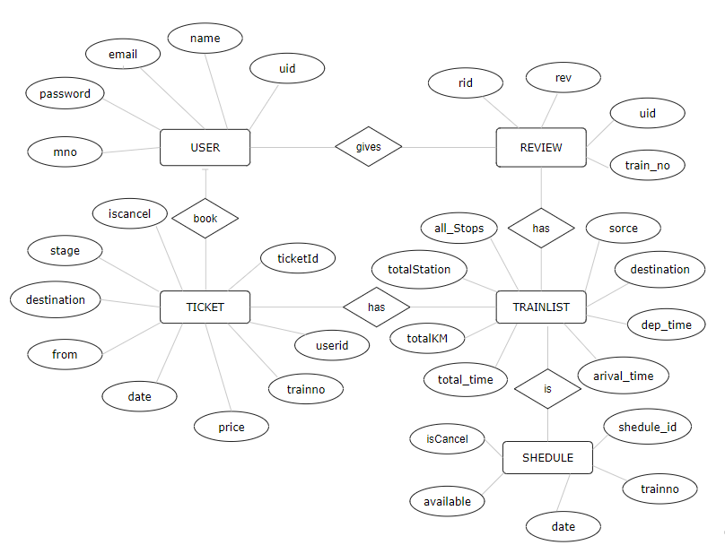

1M1

1M1

MM

1M

1M1

MM1

MM1

1M1

MM

1M1

**3. Data Dictionary Diagram:**

• **Table: user**

|  |  |  |  |  |
| --- | --- | --- | --- | --- |
| **Filed Name** | **Data Type** | **Size** | **Constraints** | **Description** |
| userid | int | 3 | Primary key | Unique id for user |
| fname | varchar | 45 | Not null | First name of user |
| lname | varchar | 45 | Not null | Last name of user |
| email | varchar | 200 | Not null | Email of user |
| pass | varchar | 45 | Not null | Password of user |
| mno | varchar | 45 | Not null | Mobile number of user |
| gender | varchar | 45 | Not null | Gender of user |
| addr | varchar | 45 | Not null | Address of user |
| gender | varchar | 45 | Not null | Gender of user |
| occ | Varchar | 45 | Not null | Occupation of user |
| bdate | varchar | 45 | Not null | Birthdate of user |
| nationality | varchar | 45 | Not null | Nationality of user |

• **Table: review**

|  |  |  |  |  |
| --- | --- | --- | --- | --- |
| **Filed Name** | **Data Type** | **Size** | **Constraints** | **Description** |
| rid | int | 3 | Primary key | Unique id for each review |
| rev | varchar | 500 | Not null | Review text given by user |
| trainno | varchar | 45 | Not null | Unique number of train |
| userid | int | 3 | Not null | Unique id of user who gave this review |

* **Table: ticket**

|  |  |  |  |  |
| --- | --- | --- | --- | --- |
| **Filed Name** | **Data Type** | **Size** | **Constraints** | **Description** |
| id | int | 3 | Primary key | Unique id of ticket |
| trainno | varchar | 45 | Not null | Unique id of user |
| userid | int | 3 | Not null | Unique id of user |
| source | varchar | 200 | Not null | Station name from ticket was booked |
| destination | varchar | 200 | Not null | Station name at passenger have to go |
| price | int | 3 | Not null | Ticket price |
| date | date | 45 | Not null | Date at which user have to go |
| km | int | 4 | Not null | Distance from source and destination |
| seatno | int | 10 | Not null | Seat number of passenger |
| Stage | varchar | 45 | Not null | Status of ticket (waiting, conform) |
| Fname | varchar | 45 | Not null | First name of user |
| Lname | varchar | 45 | Not null | Last name of user |
| mno | varchar | 45 | Not null | Mobile number of user |
| email | varchar | 200 | Not null | Email of user |
| trainname | varchar | 45 | Not null | Train name of user |
| blockNo | varchar | 45 | Not null | Block Number of User |
| selectedScheme | varchar | 45 | Not null | Scheme selected by user |
| isCancel | boolean | 1 | - | Boolean of ticket canceled or not |

* **Table : train_shedule**

|  |  |  |  |  |
| --- | --- | --- | --- | --- |
| **Filed Name** | **Data Type** | **Size** | **Constraints** | **Description** |
| id | Int | 3 | Primary key | Unique key of train scheduling |
| trainno | varchar | 10 | Not null | Number of train for scheduling |
| date | date | 45 | Not null | Date of train scheduling |
| available | int | 4 | Not null | Number of available seats |
| isCancle | Boolean | 1 | - | Boolean for canceling scheduled train |

* **Table : trainlist**

|  |  |  |  |  |
| --- | --- | --- | --- | --- |
| **Filed Name** | **Data Type** | **Size** | **Constraints** | **Description** |
| id | Int | 3 | Not null | Unique id of train |
| trainno | varchar | 45 | Not null | Unique train number |
| tname | varchar | 45 | Not null | Name of train |
| Source | varchar | 45 | Not null | Source of train |
| dtime | varchar | 45 | Not null | Despatcher time of train from source |
| Distination | varchar | 45 | Not null | Destination of train |
| Atime | varchar | 45 | Not null | Arrival time of the train at destination |
| Totaltime | int | 3 | Not null | Total time required to complete tripe |
| Totalkm | int | 3 | Not null | Total distance of tripe in KM |
| totalStation | int | 3 | Not null | Total station by train |
| avgSpeed | int | 3 | Not null | Average speed of train |
| allStopArray | text | 1000 | Not null | Array of JSON object with information about stops |

**4. Use Case, Sequence, Activity, Component, Deployment Diagram:**

* **Use Case Diagram:**

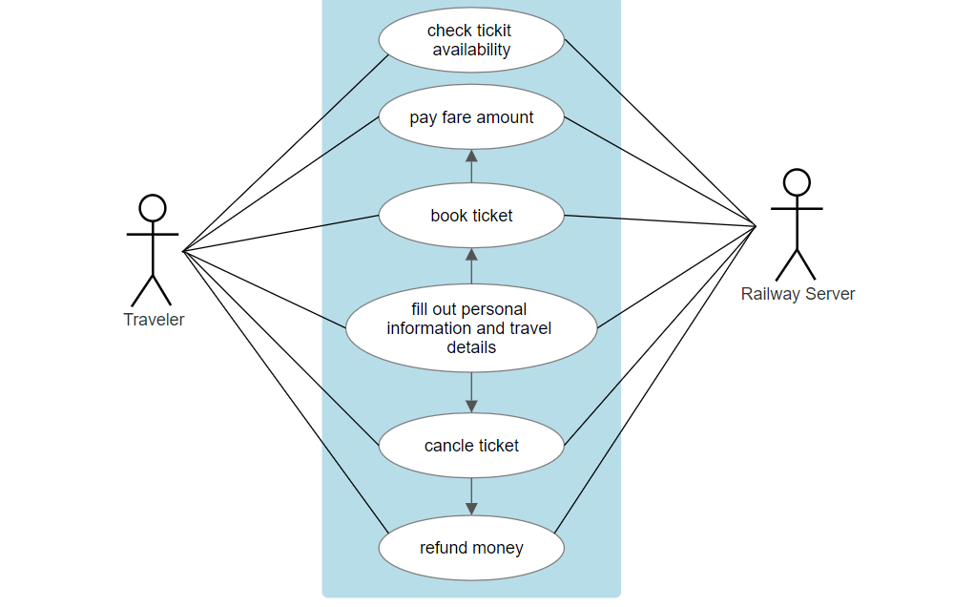

<<includes>>

<<includes>>

<<includes>>

<<includes>>

* 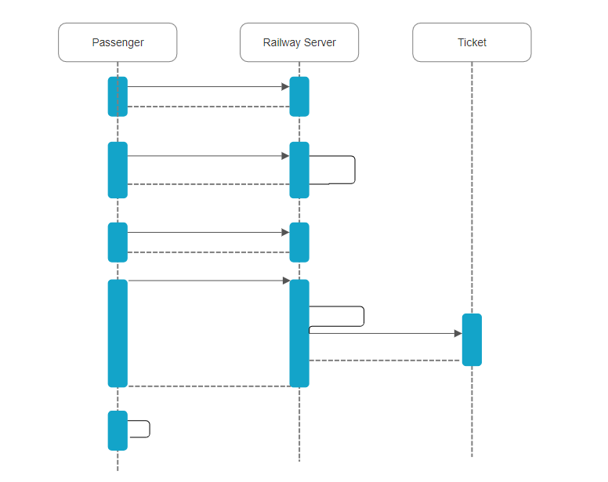**Sequence Diagram :**

Take Print

Acknowledgement

Ticket Created

Send Detail

Create Ticket

Submit Details

Request for payment

Initiating Booking

Send from

Create form

Request booking form

Send all available trains

Check train availability

* **Activity Diagram:**

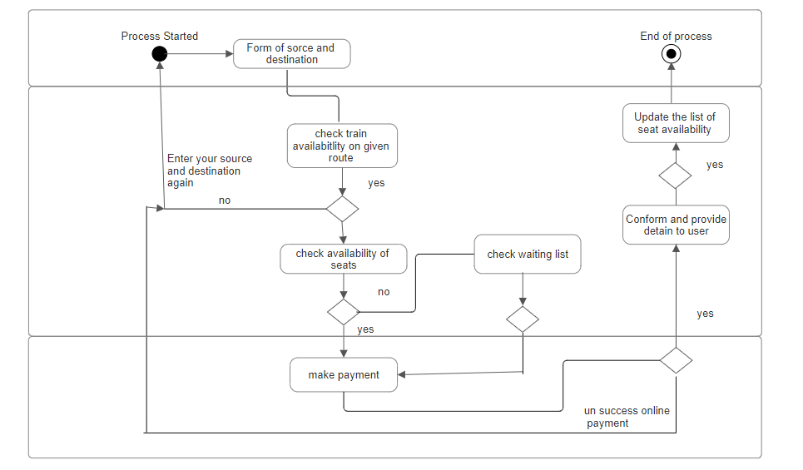



Railway server

Bank Payment

Requester

* **Component Diagram:**

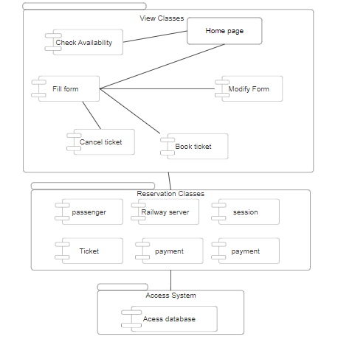

* **Deployment Diagram:**

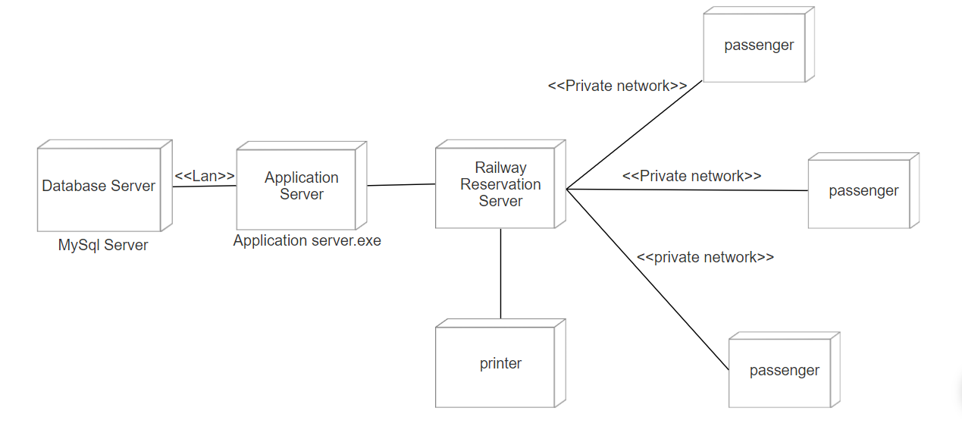

* **User Interface :**

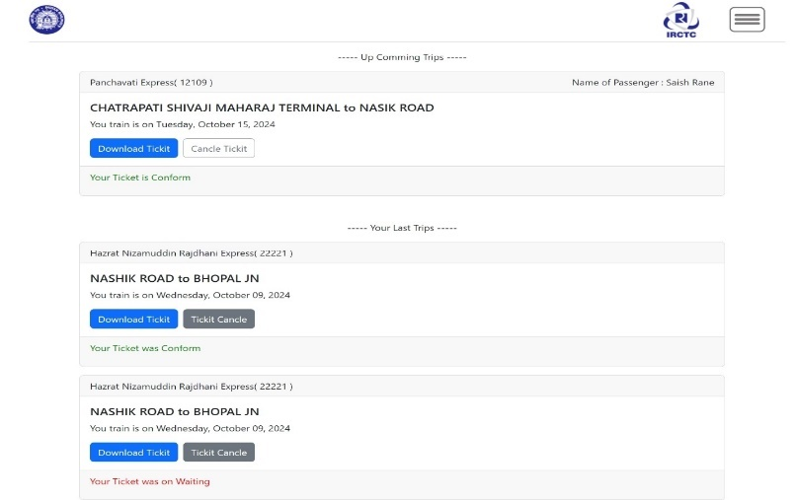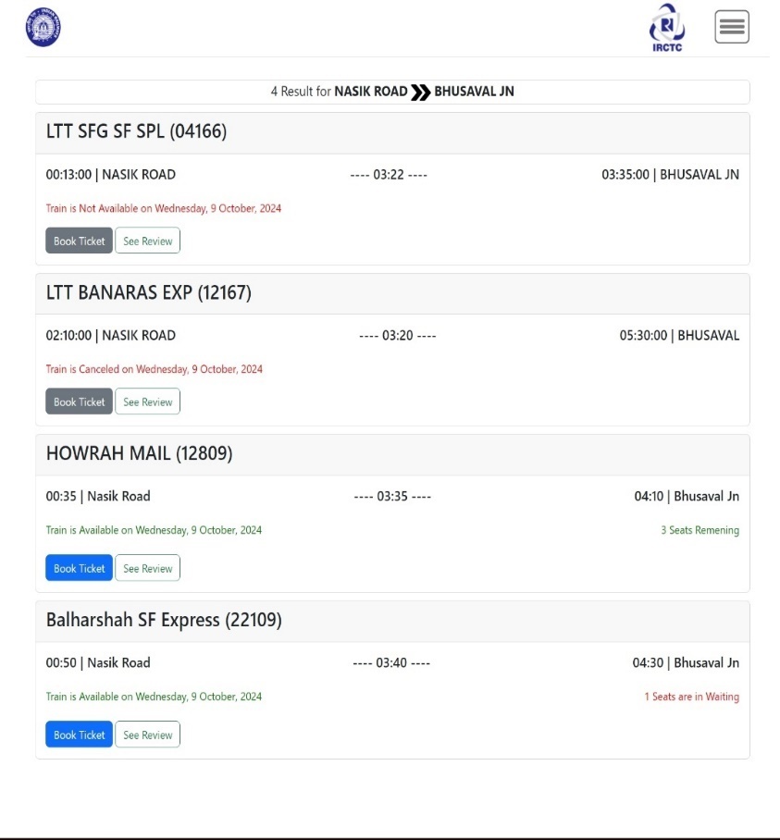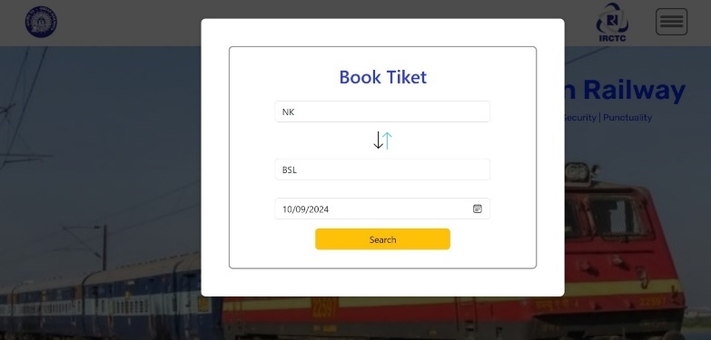

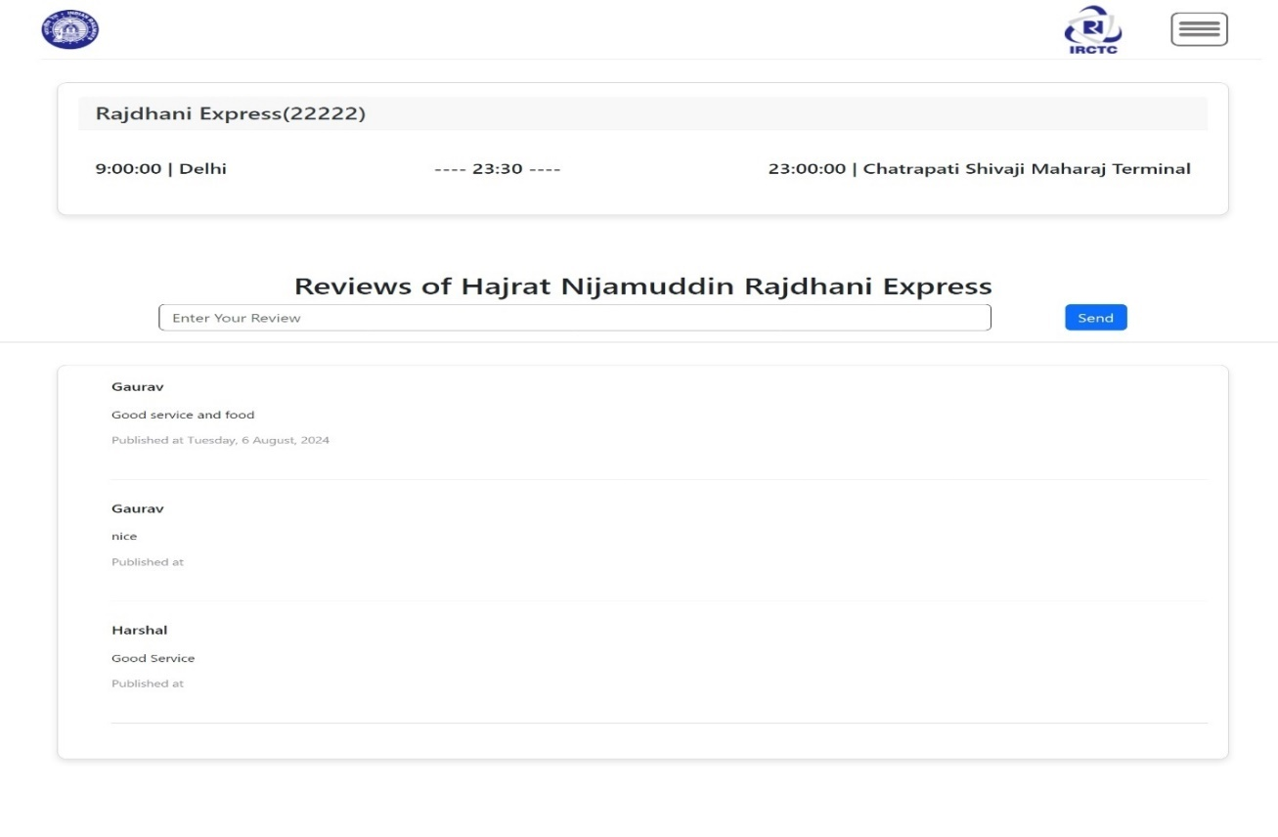

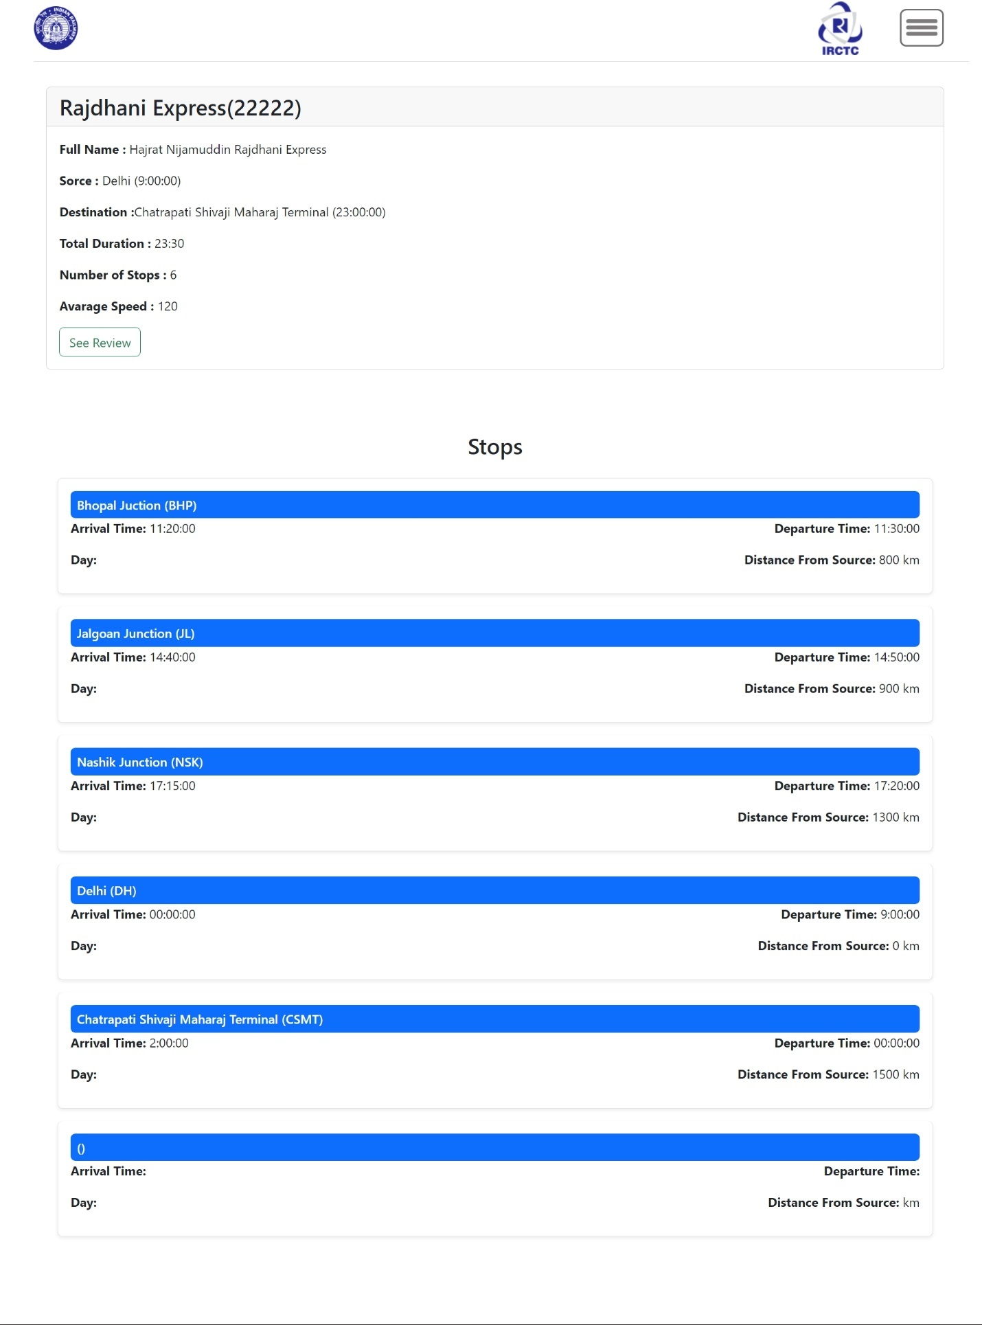

**Software and Hardware Specifications:**

**4. Implementation Details**

**Software Specifications:**

**1. Frontend Development:**

* **HTML5**: For structuring the user interface (UI).
* **CSS3**: For styling and making the UI visually appealing.
* **JavaScript**: For adding interactivity and dynamic behavior to the website.
* **jQuery**: A lightweight JavaScript library to simplify DOM manipulation, event handling, and AJAX interactions.
* **Bootstrap**: A CSS framework to make the web application responsive and mobile-friendly.

**2. Backend Development:**

* **Node.js**: A runtime environment used for building server-side applications using JavaScript.
* **Express.js**: A web application framework for Node.js, making it easier to handle requests, routing, and middleware.
* **MySQL**: A relational database management system to store and manage the data related to train schedules, user information, bookings, and reviews.

**3. Database Management**:

* **MySQL**: Used to handle data like train schedules, user data, booking details, and reviews. It supports SQL queries for data manipulation.
* **MySQL Workbench** : A visual tool for database design and management.

**4. Development Environment**:

* **Node Package Manager (npm)**: For managing dependencies and packages required in the project (like express, mysql, etc.).
* **Git**: For version control and collaboration, using platforms like GitHub or GitLab.
* **IDE**: Visual Studio Code for coding and debugging.

**5. Operating System**:

* **Windows**, **macOS**, or **Linux**: All are suitable for development, with **Linux (Ubuntu)** preferred for deployment due to stability and performance.

**Hardware Specifications:**

**1. Server Specifications** (for production):

* **Processor**: Intel Xeon or AMD Ryzen with multiple cores for handling concurrent requests.
* **RAM**: Minimum 8 GB RAM (16 GB recommended for higher user traffic).
* **Storage**: SSD (Solid-State Drive) with at least 500 GB storage to handle database files and logs.
* **Network Interface**: Gigabit Ethernet for fast and reliable communication between clients and the server.

**2. Development Machine (Local)**:

* **Processor**: Intel Core i3 or above.
* **RAM**: Minimum 4 GB RAM (8 GB recommended for smooth development).
* **Storage**: 20 GB of free space for development files, Node.js packages, and database backups.
* **Operating System**: Windows, macOS, or Linux (Linux is preferred for deployment).

**3. Database Server:**

* **Processor**: Intel Xeon / AMD Ryzen with multiple cores for concurrent query handling.
* **RAM**: Minimum 8 GB RAM (16 GB for production environments with high traffic).
* **Storage**: 500 GB SSD or higher for fast read/write operations and large datasets.
* **Backup**: Regular backups stored in an external location or cloud service to prevent data loss.

**4.Networking:**

* **Bandwidth**: Minimum 100 Mbps for handling user requests efficiently.
* **Cloud Hosting (Optional)**: Services like AWS, Google Cloud, or DigitalOcean for scalable infrastructure.
* **Load Balancer** (Optional): For distributing incoming traffic evenly across multiple servers, improving reliability.

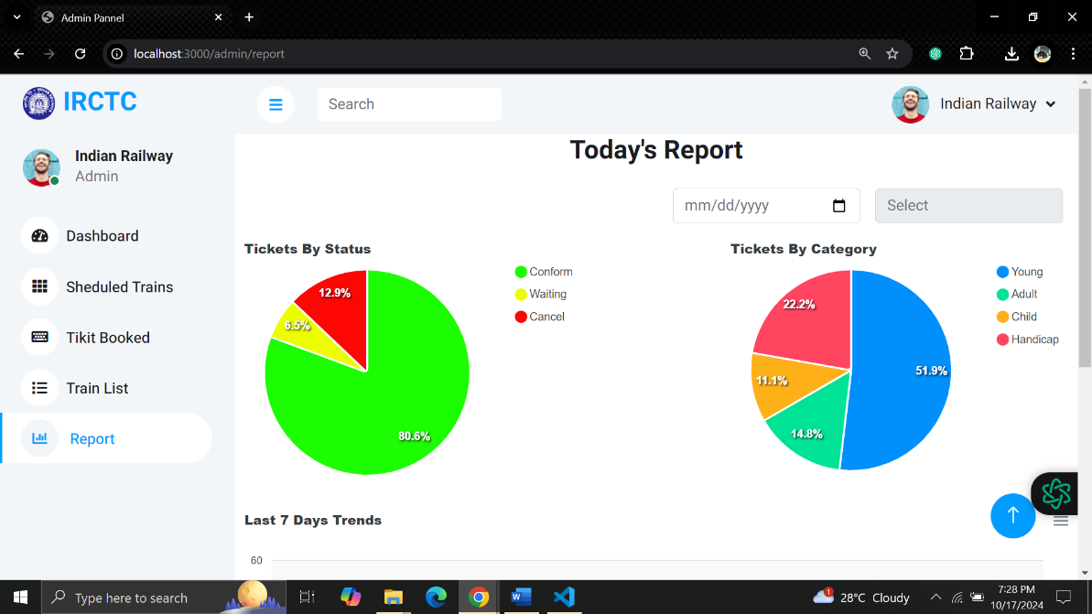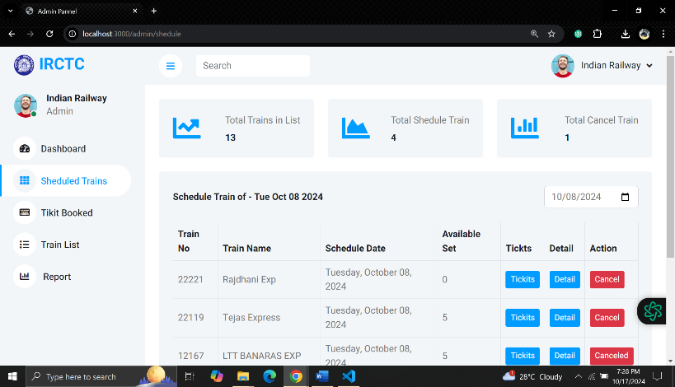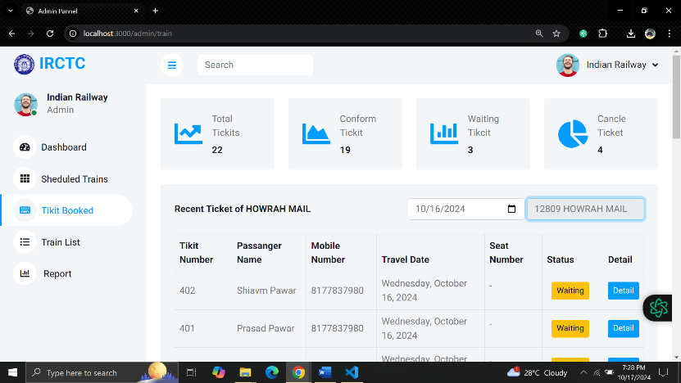

**5.Ouputs and Reports Testing**

